Transaction line fields
Sales order example: https://173465-sb1.app.netsuite.com/app/accounting/transactions/salesord.nl?id=5640&scrollid=5640&whence=&cmid=1635960771089_2273
If fields are not filling up on the item table:
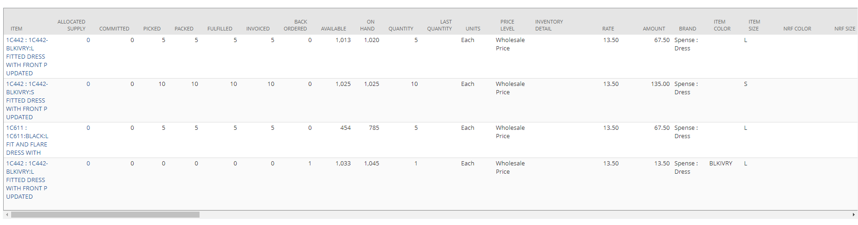
Then perhaps we have to check that data is filled correctly and check which is the id, to do this.
To double check, we go to the item and inspect it’s retail apparel (Right click on item, and open in a new tab):
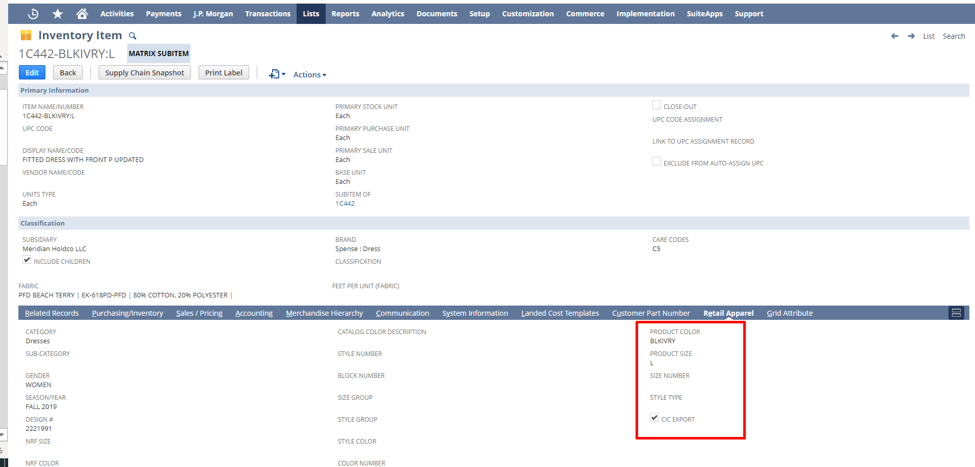
Here we can check some of the fields may not be correctly charged.

To fix this we go to Customization -> List, Record & Fields -> Transaction Line Fields:
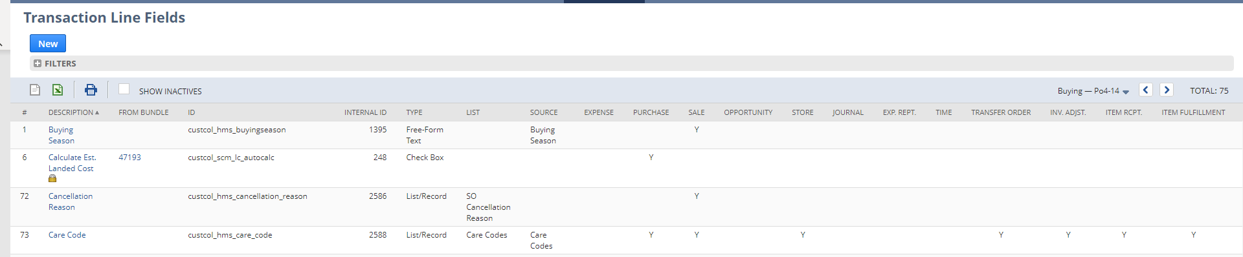
Select Care codes.
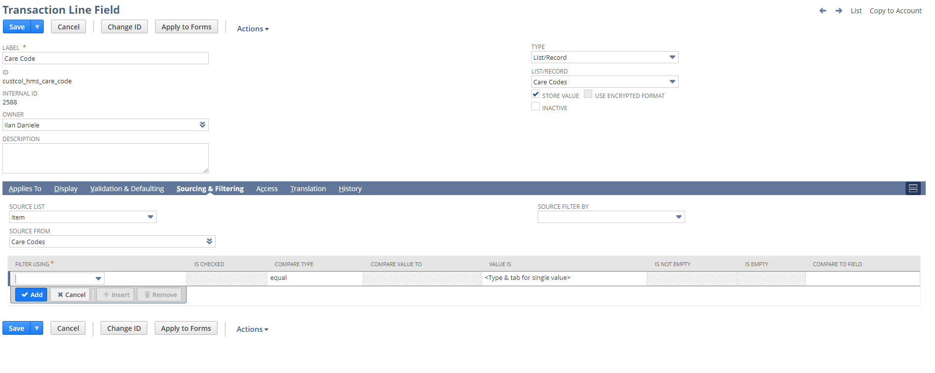
Change data needed from sourcing & filtering, and check where everything is needed.

Add transaction line field
Customizations -> List record and fields -> new transaction line -> new
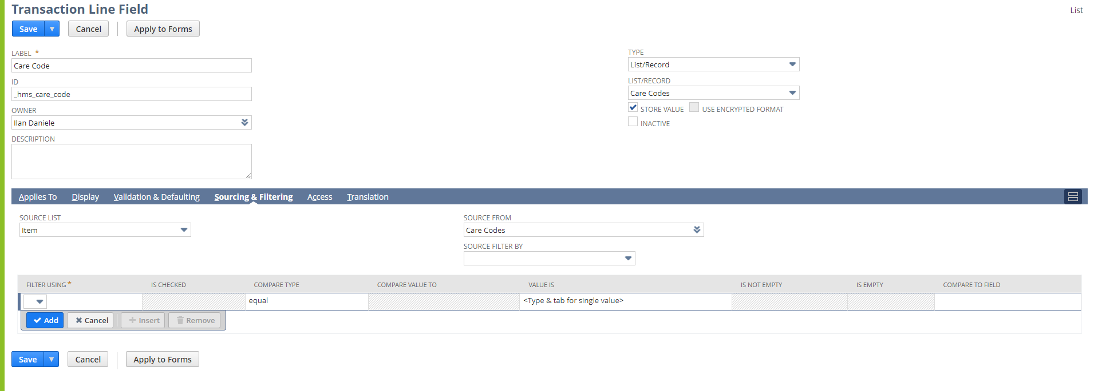
Go to script deployment -> Parameters -> copy value: NSCS | SO Search
Go to it -> edit this search and then results:
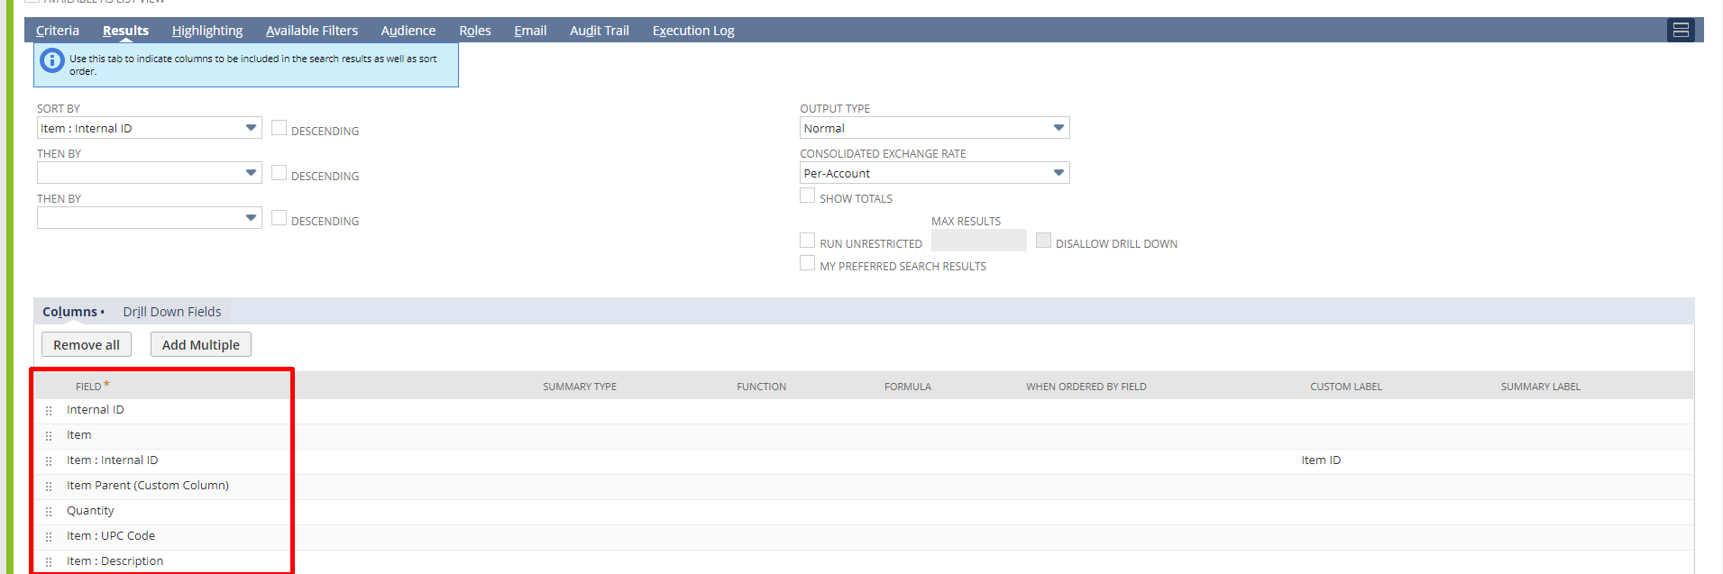

Y en la NSCS | matrix search:
